Project :- Deploy NODE JS application on AWS using ECR and EKS
WORK FLOW :-
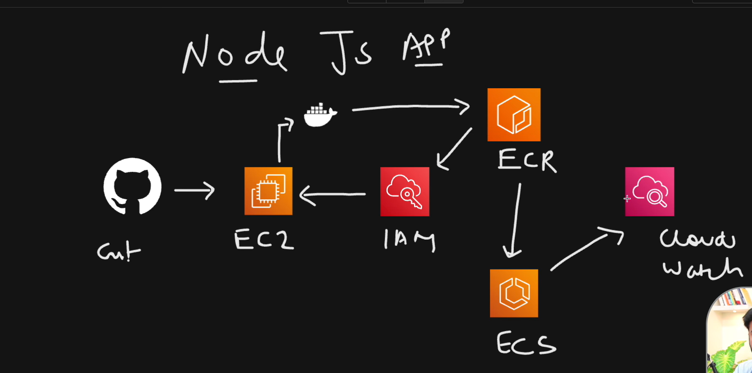
Steps to start the project :-
- Create one EC2 instance to install git and docker to setup our docker file
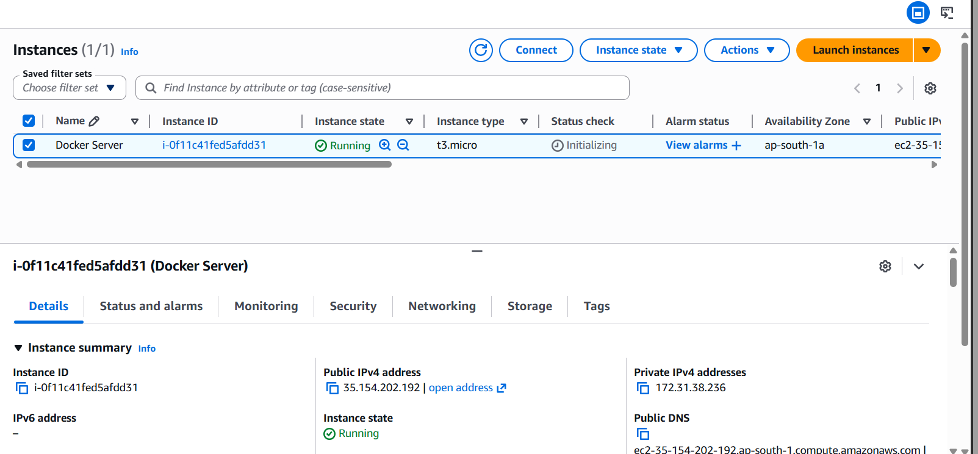
2. Login into instance using CMD :-
Command to login :-
ssh -i Vanshit.pem ubuntu@35.154.202.192
3. Install docker on instance :-
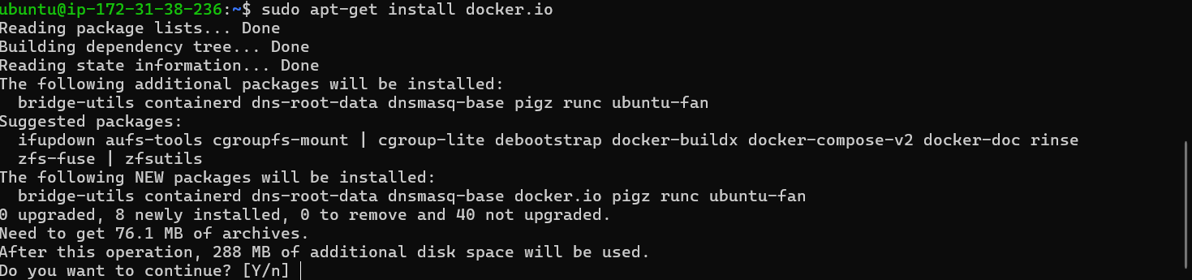
Note :- You don’t have permission on local user of docker ps etc , hence u have to add to the group of docker
After this reboot the system
4. Clone your repository from GIT Hub
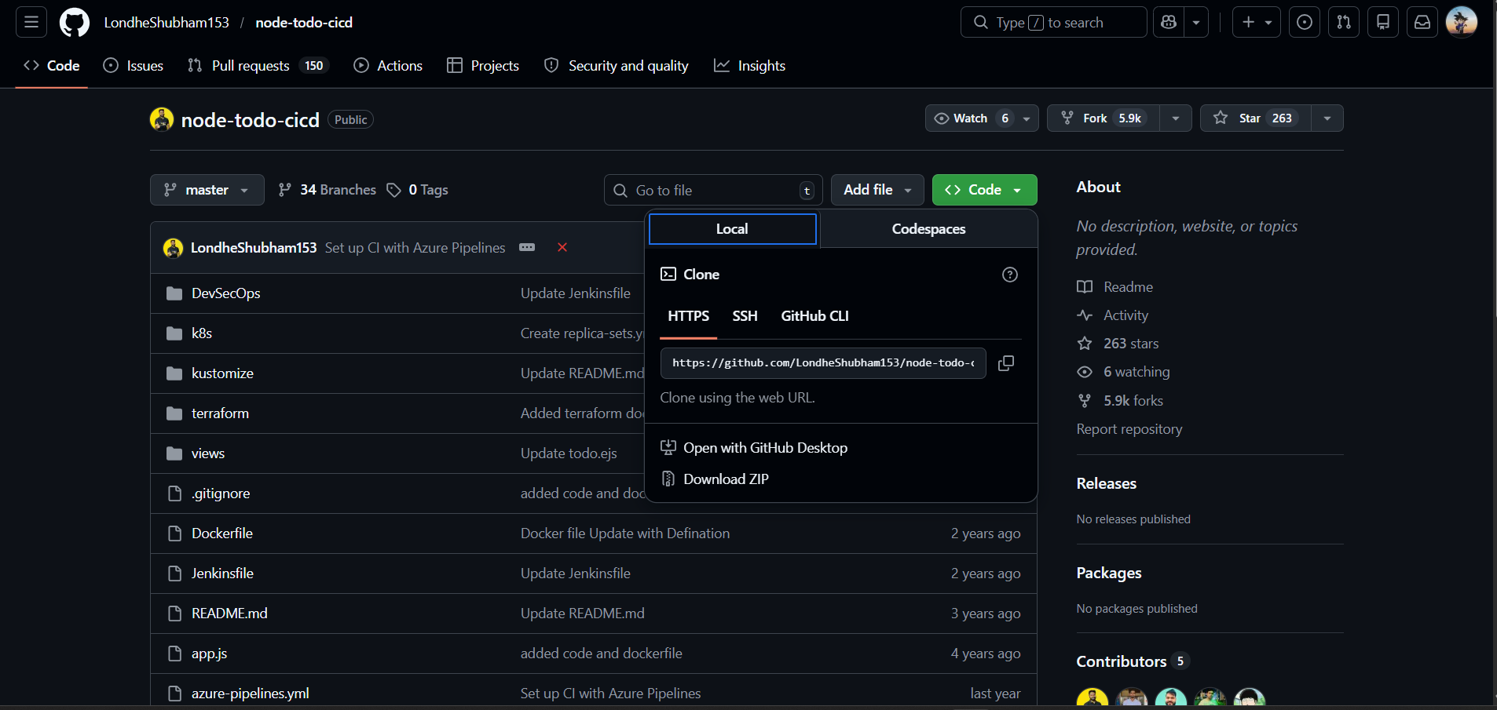
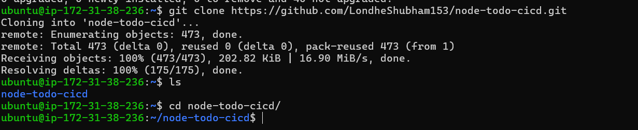
5. Now create ECR (elastic container registry) REPO in AWS
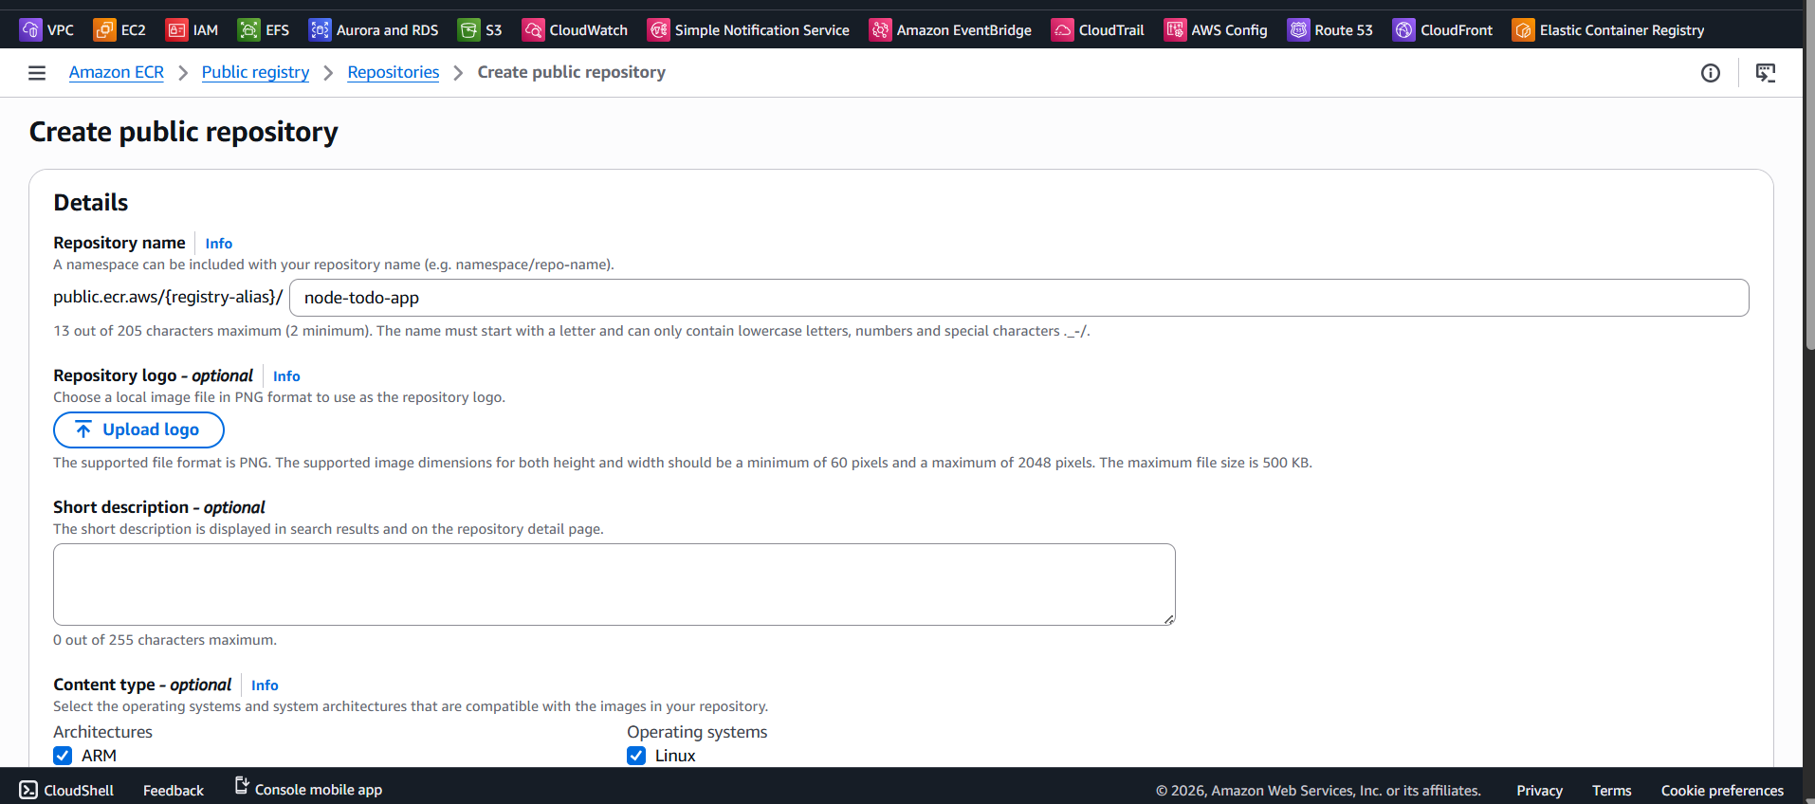
6. Make sure that you have the latest version of the AWS CLI and Docker installed
Install Aws Cli in instance
Install unzip also
Command to install :-
curl "https://awscli.amazonaws.com/awscli-exe-linux-x86_64.zip" -o "awscliv2.zip"
unzip awscliv2.zip
sudo ./aws/install
7. Now to run ECR in ubuntu u have to give AWS credentials that measn Access key and secret key create user using IAM service
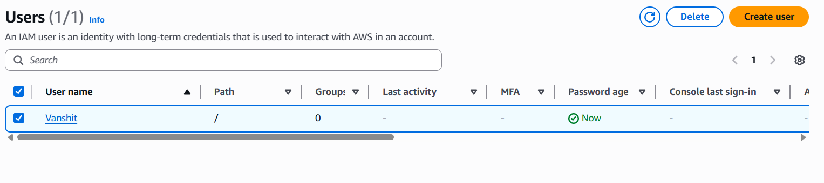
We have created user and given Administrator access.
Now u have to create Access key
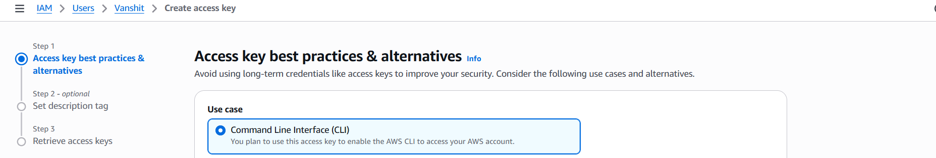
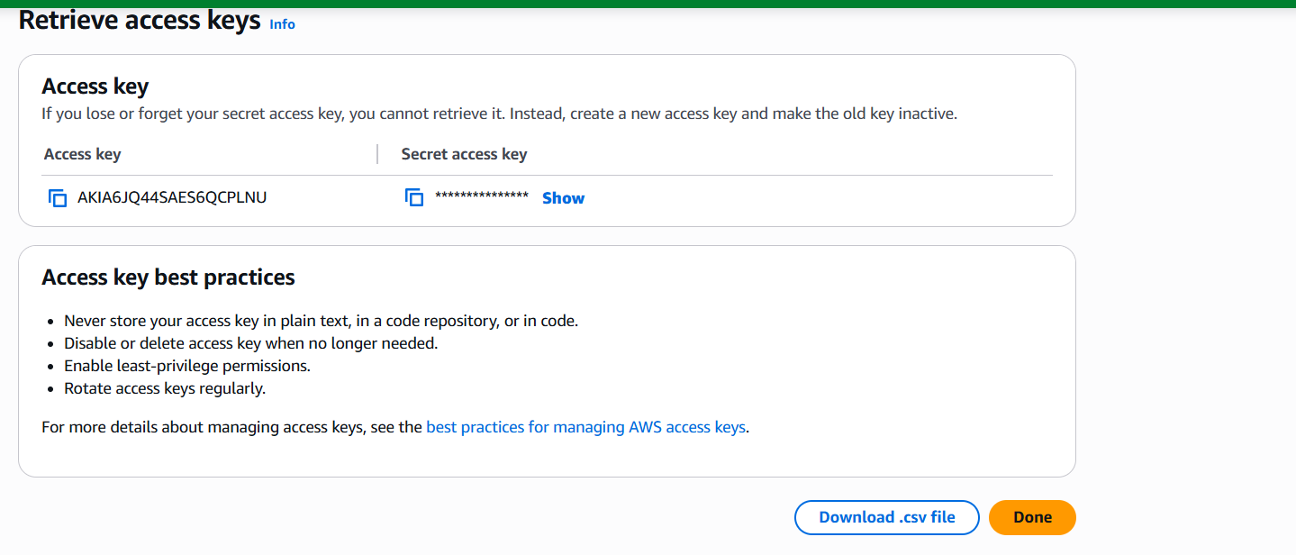
8. Now go to instance and use aws configure
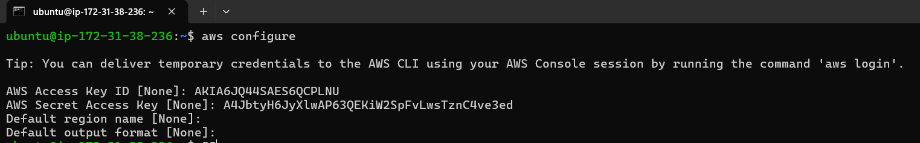
9. Now use this command to login into ECR
10. Now build the docker file you clone from github
docker build -t node-todo-app .
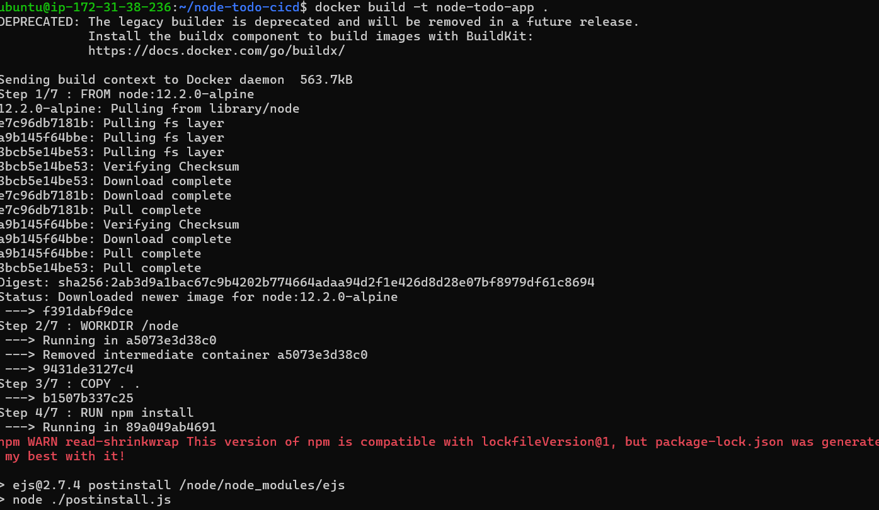
11. Now u have to Tag the image u build
Command :-
docker tag node-todo-app:latest public.ecr.aws/e8z8o8h4/node-todo-app:latest
12. Now u have to push your docker image to ECR using this command
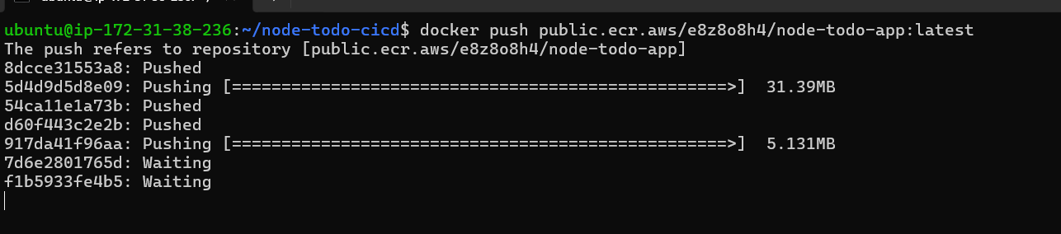
Image is being pushed u can see in your ECR repository
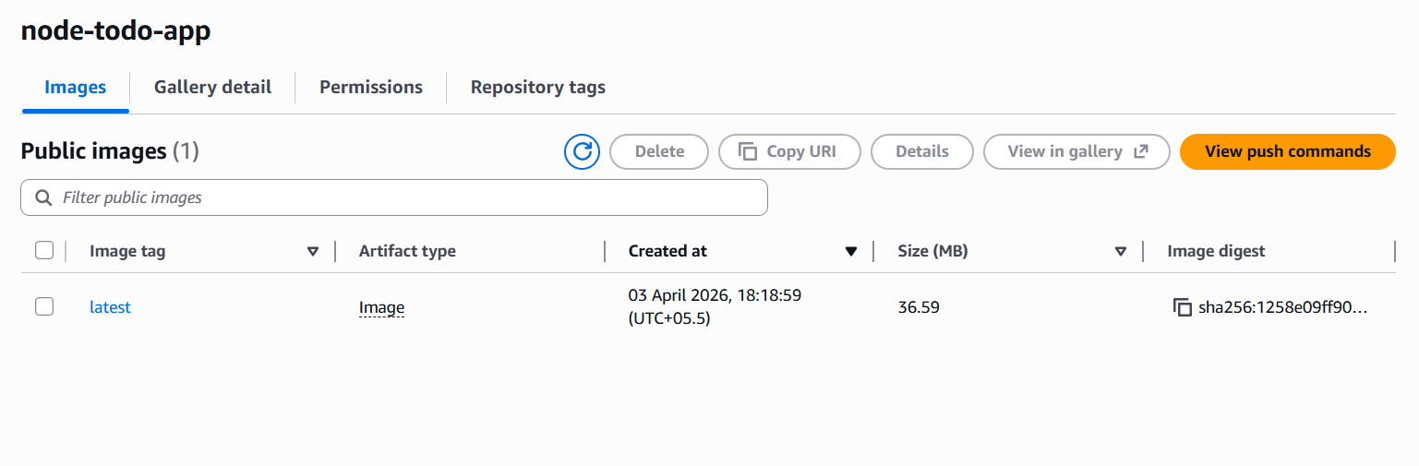
13. Now go to ECS service (Amazon Elastic Container Service)
Create cluster
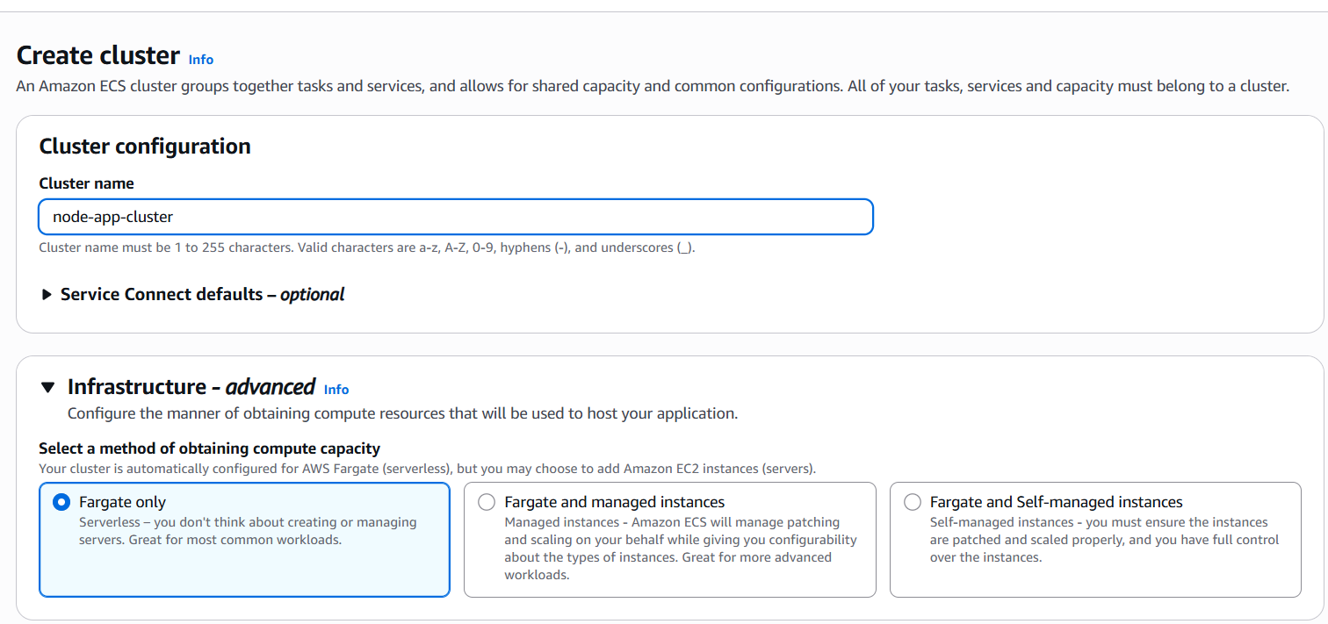
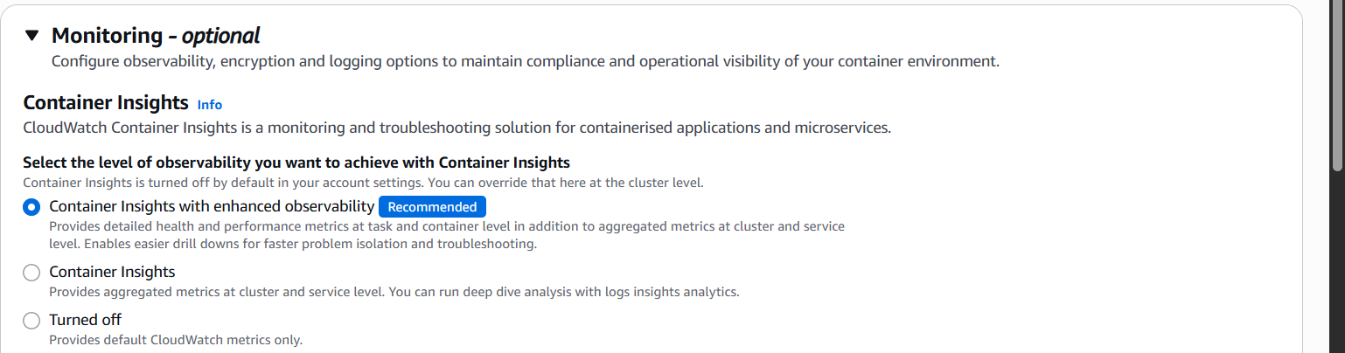
Now u have to run the container using ECS to run the image of docker u push to image using ECS u have to create task definition to run the container from image to understand task definition refer below
🧠 Task Definition (ECS) — Simplest Meaning
👉 Task Definition = Blueprint of your container

📦 In Simple Words
It tells AWS:
👉 What to run
👉 How to run it

🧾 What It Contains (Keep it simple in notes)
- Docker image name
- CPU / Memory
- Port number
- Environment variables
- Command to run

🎯 One-Line Interview Answer
👉 Task Definition is a configuration file that defines how a container should run in ECS.

🧠 Example
If you want to run nginx:
Task Definition says:
- Use nginx image
- Run on port 80
- Allocate memory
- Start container

🏗 Flow in ECS
Task Definition
⬇
Task (running instance of it)
⬇
Service (keeps tasks running)
By the time I was creating cluster I got an error of not creating the cluster it asks me to create a role of ECS service
This is how I solved that I created a role name ecs-role and attached policy AmazonEC2ContainerServiceRole and then my cluster created .
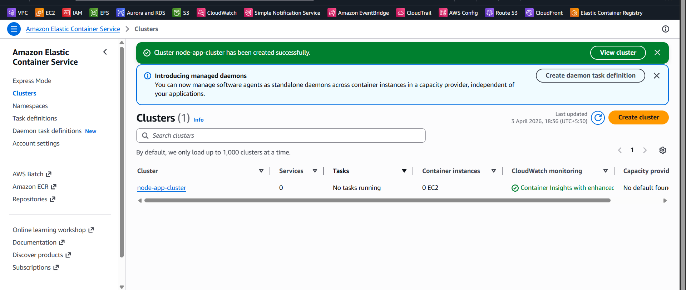
Now create tasks to run the container
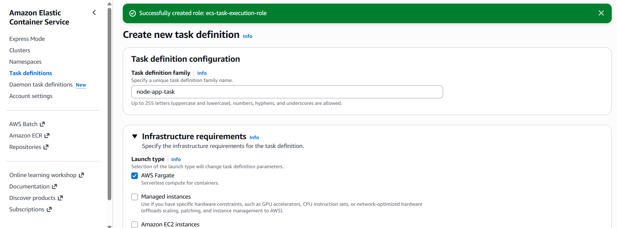

In this u have to create a role of having permission AmazonECSTaskExecutionRolePolicy
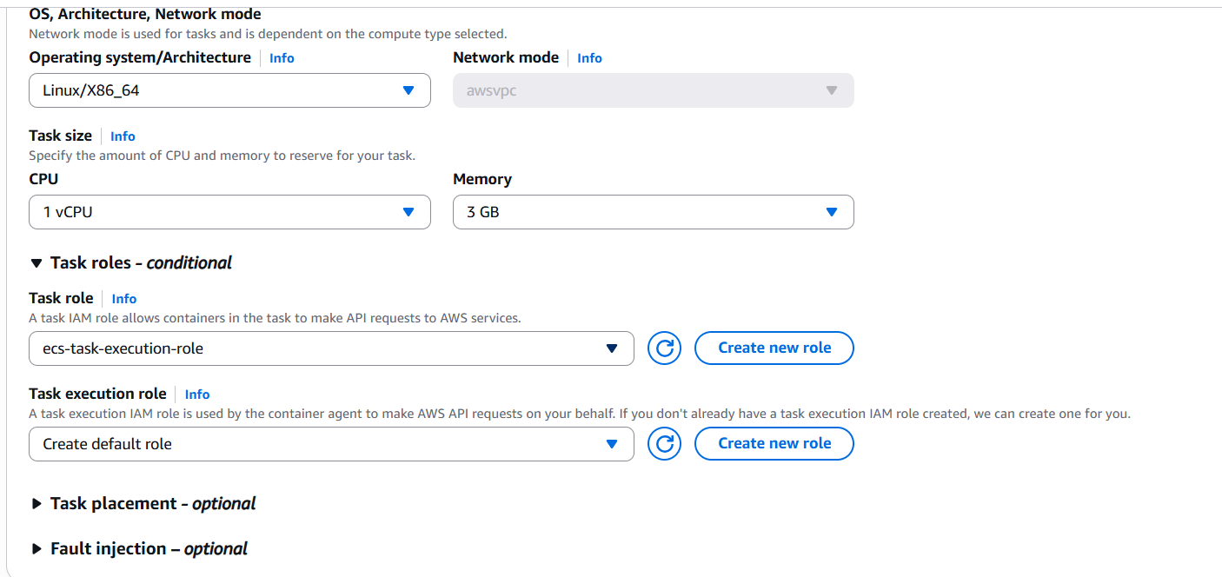
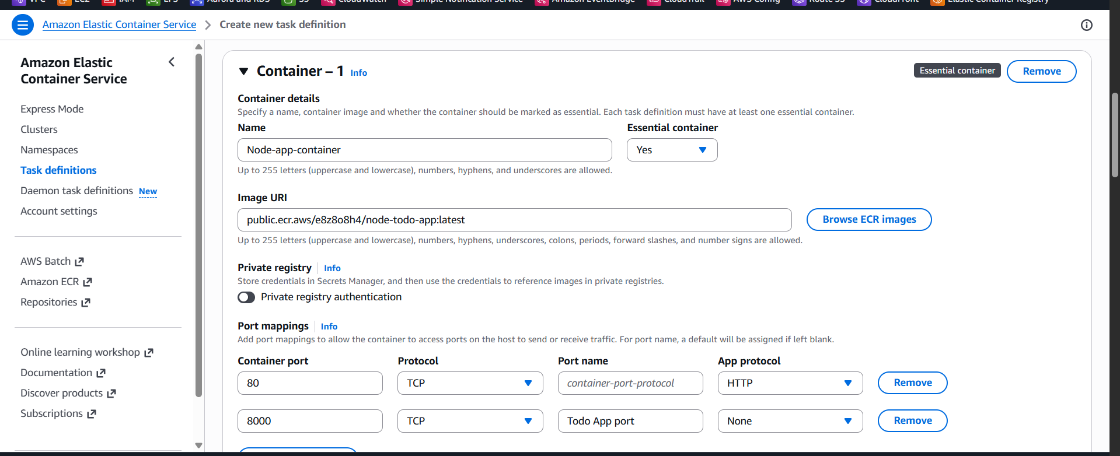
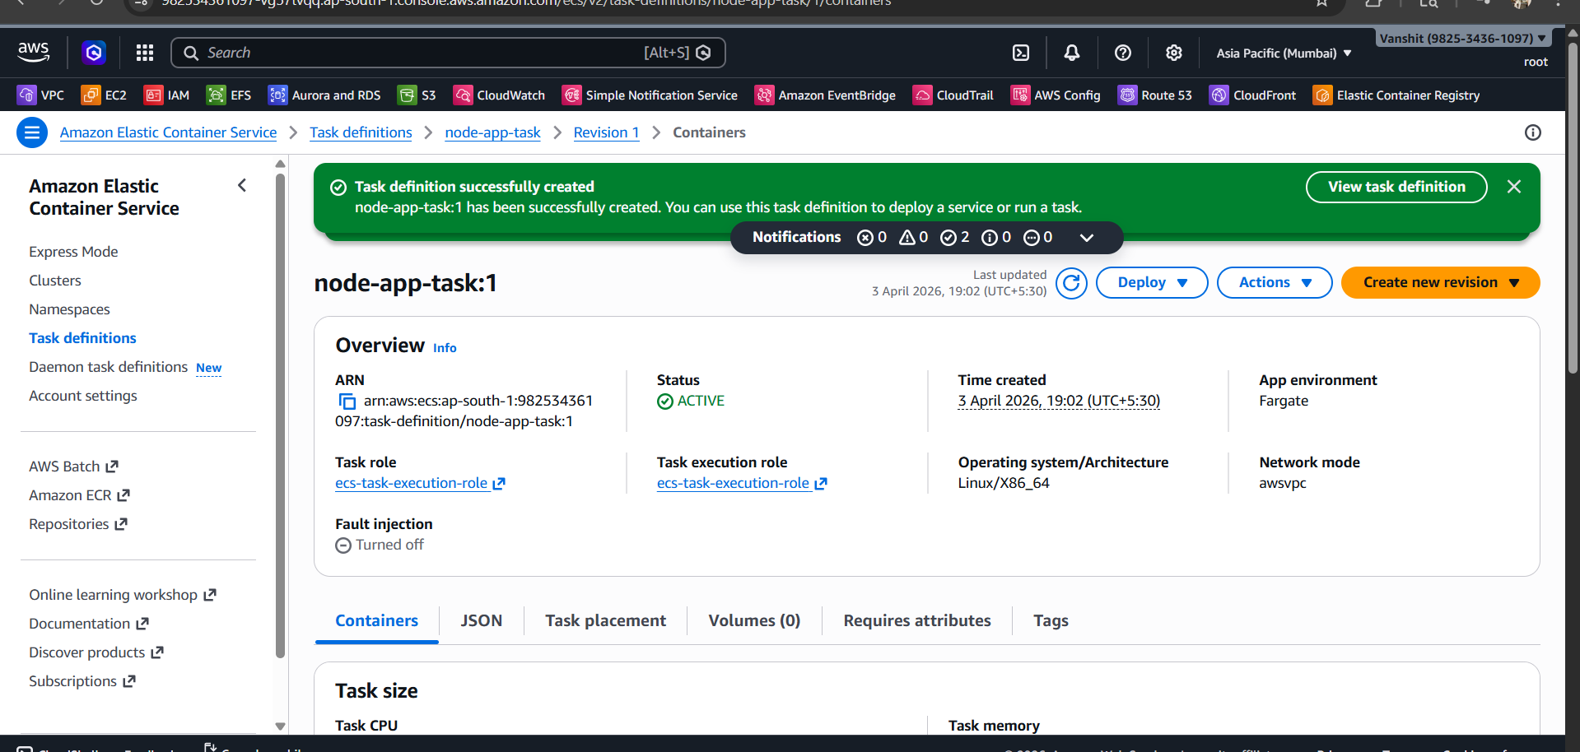
Now ur task is being created to run go to deploy option and run task
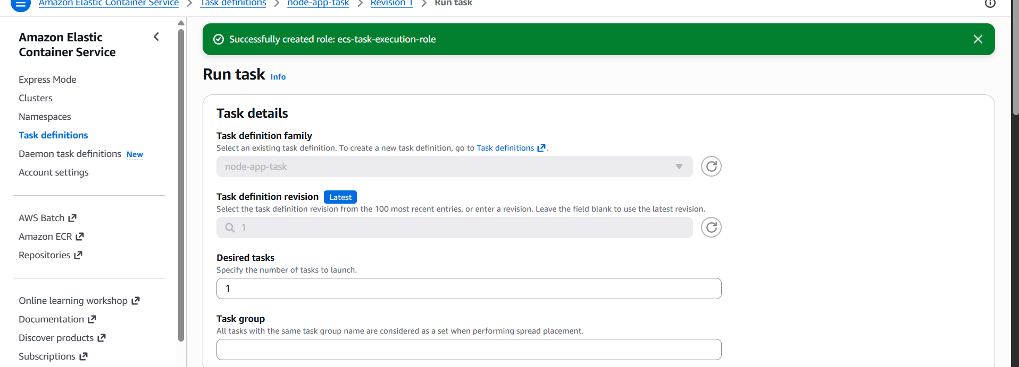
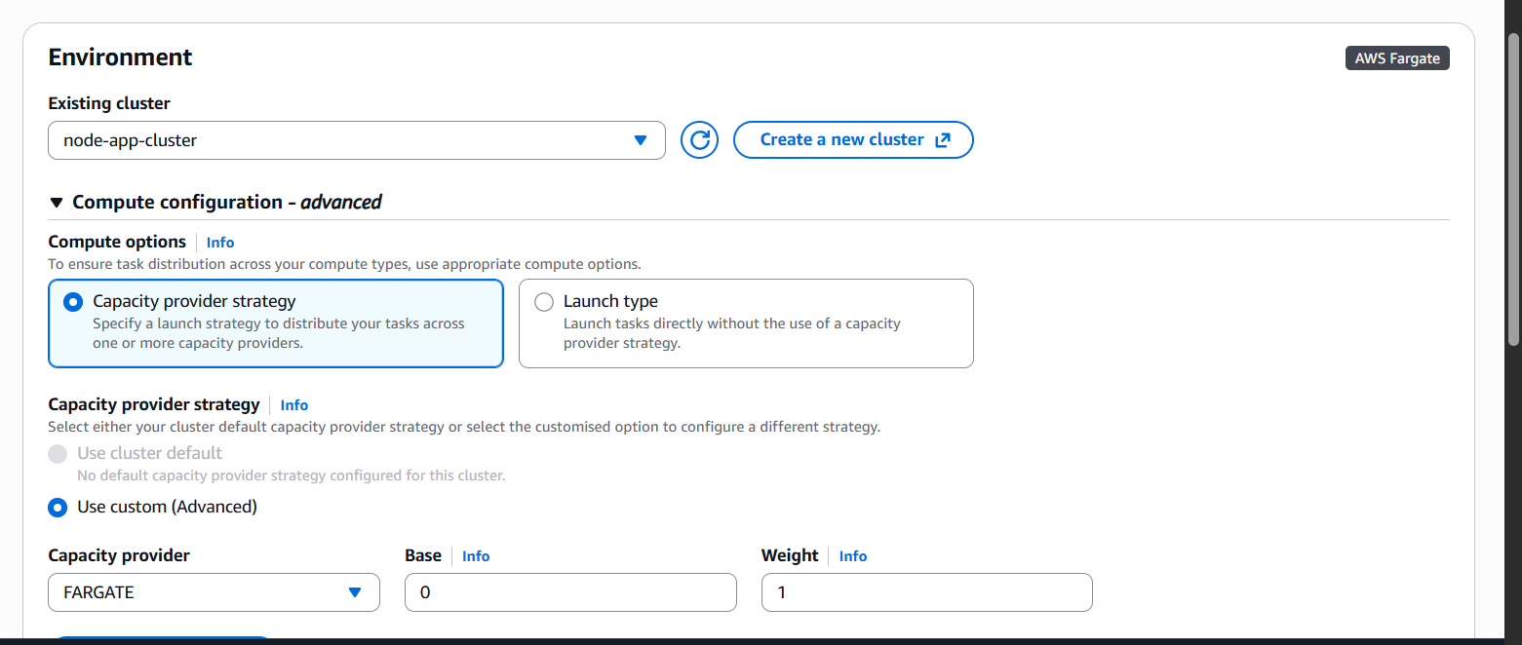
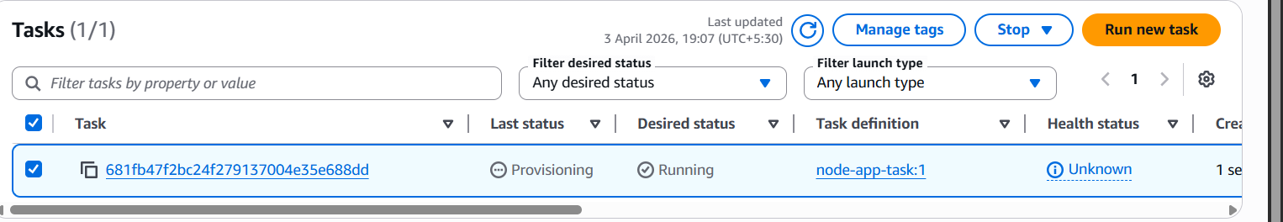
Now to see the results click on task and u will get the public IP
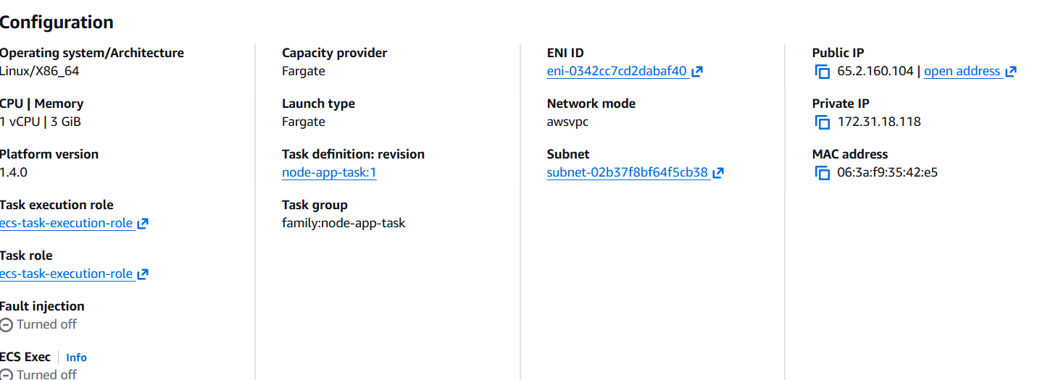
ERROR :- At the time I was running the public ip:8000 I was not able to reach the destination so what we have to do click on ENI id and go to security groups and add a port of 8000 and then u will get to see the results
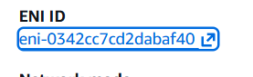
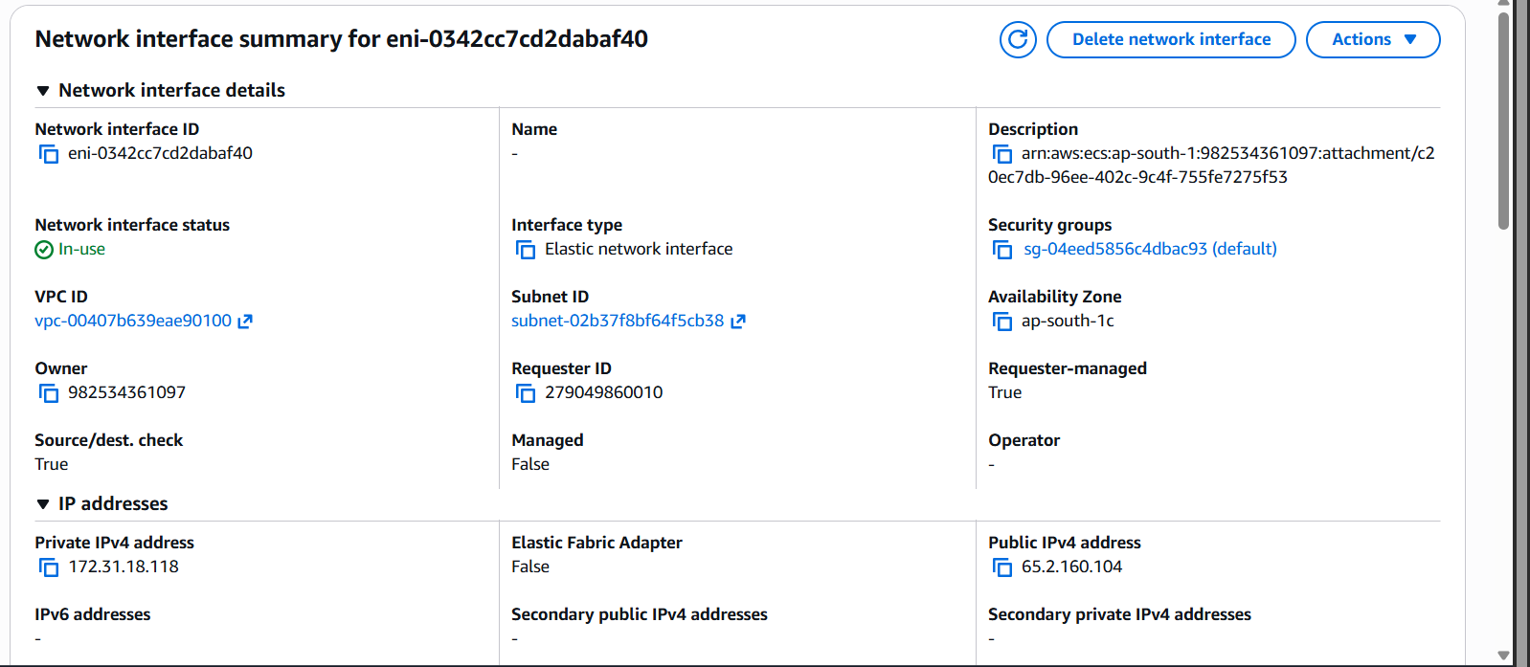
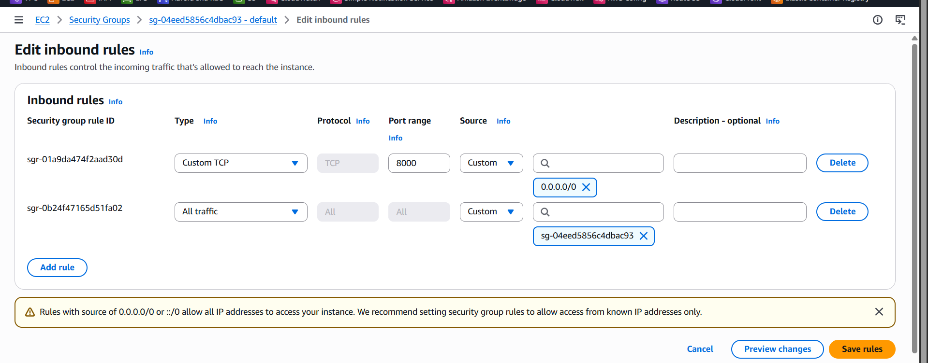
Here are the results of your project
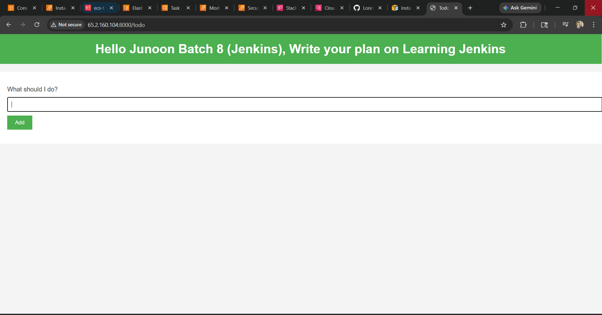
Now we will be able to see the logs in cloudwatch
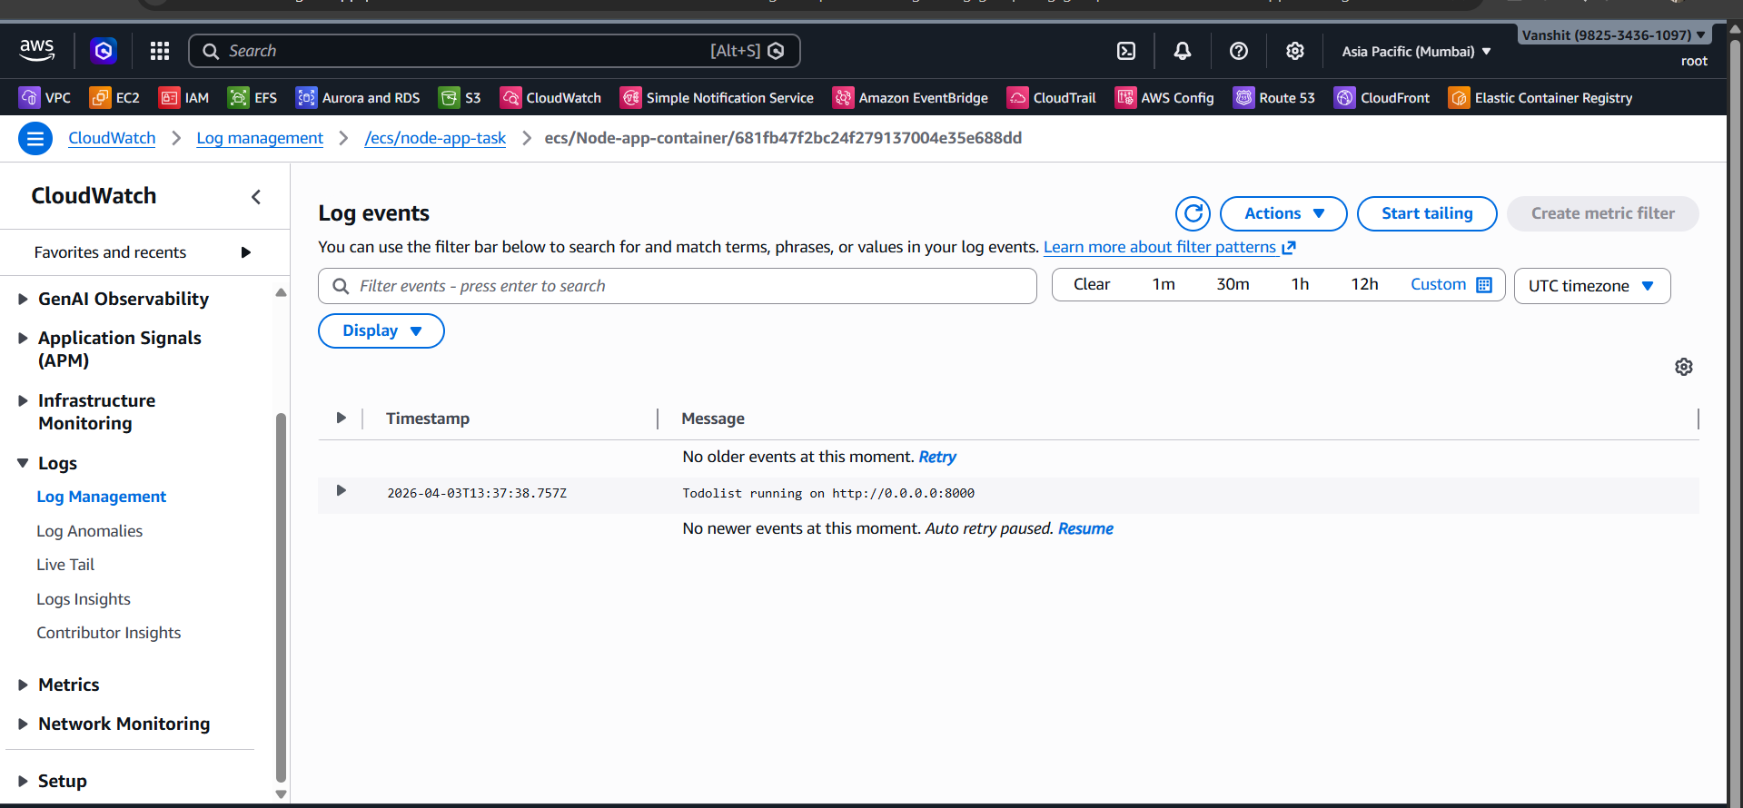
You completed the project successfully.

